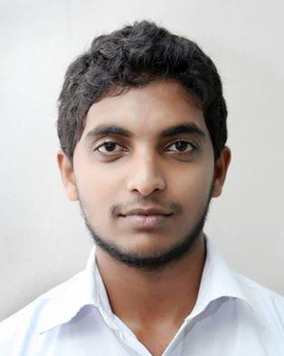
M.P.L. PEIRIS
No.35/C,Shramashakthi Mawatha, Egodauyana, Moratuwa

Tel: - 0777726003, 0112658629
    - Email: - pramodhsgallery@gmail.com
Language Skills : Fluent English

CARRIER OBJECTIVE | To take my career to a high level by taking on challenging jobs that emphasized on quality image and loyalty building. To also acquire knowledge and experience in a multitasking environment and more so to contribute and associate with excellence and high achievement.
WORKING EXPERIENCE  ACADEMIC  &  PROFESSIONAL  QUALIFICATION  EXTRA CURRICULAR ACTIVITIES  PERSONAL  INFORMATION | - Blink Photography & Studio 2011 to date  Vajira Road, Colombo 04.  (Summary: At the moment I am working as a Creative Designer & assistant  Coordinator at Blink Photography & Studio since 2011 to date.)  - Explanation of new packages  - Back office (Filing, email, photo copy & fax)  - Making Albums  - Graphic Designing with new technology  - Wijaya Graphic & Animation center Sri Lanka  (Summary: I have Been worked as a training Lecture at Wijaya graphics and animation center Sri Lanka since 2010 to date.)  - I Have Passed General Certification Ordinary Level Exam in 2007 conducted by Department of Examinations in Sri Lanka.  - Sinhala - A  - Commerce & Business Studies - A  - Science - B  - English - B  - Geography - B  - Social Studies - B  - Mathematics - C  - Buddhist - C  - Western Music - C  - I Have Passed General Certification Advance Level Exam in 2009 conducted by Department of Examinations in Sri Lanka. ( Commerce Streams)  - Accounts - B  - Economics - C  - Business Studies - C  - Completed a Diploma in Multimedia at Wijeya Graphics & Animation Centre Sri Lanka.  - Excellent skills in computer applications relevant to commercial  - Graphic Designing & Animation  - I was a member of School Commerce Society  - Active member of College Buddhist Society  - I was a Senior Copral of College Western Cadet band since 2007 to 2009.  - Name : M.P.Lahiru Peiris  - Date of Birth : 03rd of February 1990  - NIC No. : 900342284V  - Marital Status : Married  - Sex : Male  - Nationality : Sri Lankan  - Languages : Fluency in English Speaking, Writing & Reading  - School attended : Prince Of Wales College , Moratuwa  I do hereby certify that given particulars furnished by me are true and correct to the best of my knowledge.  ______________________ ______________________  Date M.P.L.Peiris

